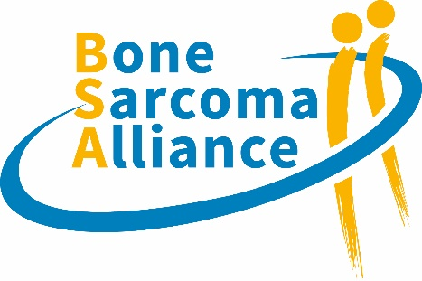

**OUR GOVERNANCE PRINCIPLES**

*(Status Jan 17, 2024)*

1. The Bone Sarcoma Alliance (BSA) is not a registered organization but an *informal partnership* initiative composed of patient groups/organizations, patient/parent advocates and patient networks. Individual patients are not admitted unless they qualify as patient/parent advocates or patient experts.
2. The Bone Sarcoma Alliance is an initiative arising from Sarcoma Patient Advocacy Global Network (SPAGN) and the patient/parent group of the Fighting Osteosarcoma Through European Research (FOSTER) consortium with the common aim of amplifying the voice of all bone sarcoma patients beyond specific bone sarcoma types, to raise awareness about the burden of bone sarcomas and tackle common issues. Sharing experiences is the first step to better identify common challenges and define priorities of action.
3. Members of the Bone Sarcoma Alliance align with the mission and vision of the Sarcoma Patient Advocacy Global Network and the mode of operation of the Bone Sarcoma Alliance as well as the major governance principles. Exclusion from the Bone Sarcoma Alliance is permissible only if there is an important reason. Such a reason can be a serious breach of the interest of SPAGN or the BSA or the SPAGN statutes on several occasions. Membership in the Bone Sarcoma Alliance is independent of membership within SPAGN.
4. Its main mode of operation will be *'working together as partner*s' as part of the SPAGN umbrella. All partners that align with the BSA 'vision' and its overarching goals are welcome to join and sign this document to work together.
5. In order to ensure equal and fair representation, all decisions will be taken democratically. All decisions are based on majority-voting system and always taken in a fully transparent way. All decisions require a simple majority of the member partners present at the meeting. Each partner has one vote. This applies to all decisions taken by any working/project group created by the partnership.
6. A Steering Committee oversees the overall scope of the initiative and provides guidance. The steering committee (SC) is composed of 3-4 members always including a SPAGN representative. SC members serve for 2 years and can be renewed by the members of BSA.
7. For new projects, project leaders can be selected according to knowledge and expertise regardless of the SC.
8. SPAGN creates a BSA site on its website, promotes relationships through its global network, provides a central point of contact, serves as administrative support and sets up a shared drive to upload relevant documents and publications.
9. Regular meetings, set by SPAGN, are scheduled every two months. During all meetings at least one member of the steering committee needs to be present. Each meeting will be recorded. Two attendees will be selected for a period of three months to share duty of minute keeping and send out reminders for meetings.

**OUR MAJOR GOVERNANCE PRINCIPLES**

Our overarching guiding principles to ensure commitment, integrity and accountability.

* Working together as partners
* Shared values
* Global inclusivity
* Equal representation and equal say
* Transparency

**OUR CURRENT STEERING COMMITTEE:**

* Ornella Gonzato, Sarcoma Patient Advocacy Global Network &   
  Fondazione Paola Gonzato-Rete Sarcoma ETS
* Pan Pantziarka, FOSTER Patient/Parent Working Group &   
  George Pantziarka TP53 Trust
* Zoe Davison, Bone Cancer Research Trust (BCRT)

**SPAGN Team**: Kathrin Schuster & Ivana Angelovska

**Contact**: [bonesarcoma@sarcoma-patients.org](mailto:bonesarcoma@sarcoma-patients.org)